Aysha Sumaiya, Wince Glory, Eduardo Reyes, Anne Bezwada, Nina D’Amico

Professor Tima Kshetry

INST 327 - Project Plan

21 February 2022

Project Plan

Our team meeting plan is to communicate through GroupMe to establish the best meeting times. We will meet on Zoom every Monday at 5 PM to work on the project for an hour, and our backup day will be Wednesday at 10 AM. Moreover, we will schedule an additional day if needed.

Team members will divide work fairly and contribute equally to assignments. If a team member cannot complete the assigned part, he/she needs to let us know during scheduling so we can complete it as a group. Team members will communicate actively and honestly. All the documents, files, and links will be shared through Google Drive, where everyone can access at any time and day.

**The Team Roles and Responsibilities for this Project**:

| Name | Role | Responsibilities |
| --- | --- | --- |
| Anne Bezwada (*Primary Contact*) | Liaison | * Ensure that the team meets the deadline for each section of the project * Aid in improving the quality of the codebase. * Track development progress |
| Aysha Sumaiya (*Secondary Contact*) | Alternate liaison | * Assure the data quality and integrity in databases * Plan schedules according to the assignment deadline. |
| Wince Glory | Error checker & Check Syntax of the code | * Responsible for fixing any issues related to the database * Test databases and perform bug fixes |
| Nina D’amico | Researcher & Presenter | * Gather enough data for the project * Prepare documentation for database applications * Posting the updated project version on Google Drive |
| Eduardo Reyes | Presenter & Researcher | * Prepare documentation for database applications * Preparing the final presentation of the project * Help write and optimize in-application SQL statements |

Our project milestone over the next three months is displayed down below. We will have six major deadlines for this project that the team will follow. However, we will meet with the TA or the Professor between those due dates to get feedback on our progress. The project stages will be completed 3 days prior to the actual date. This will give extra days if we are confused or have trouble with the project. 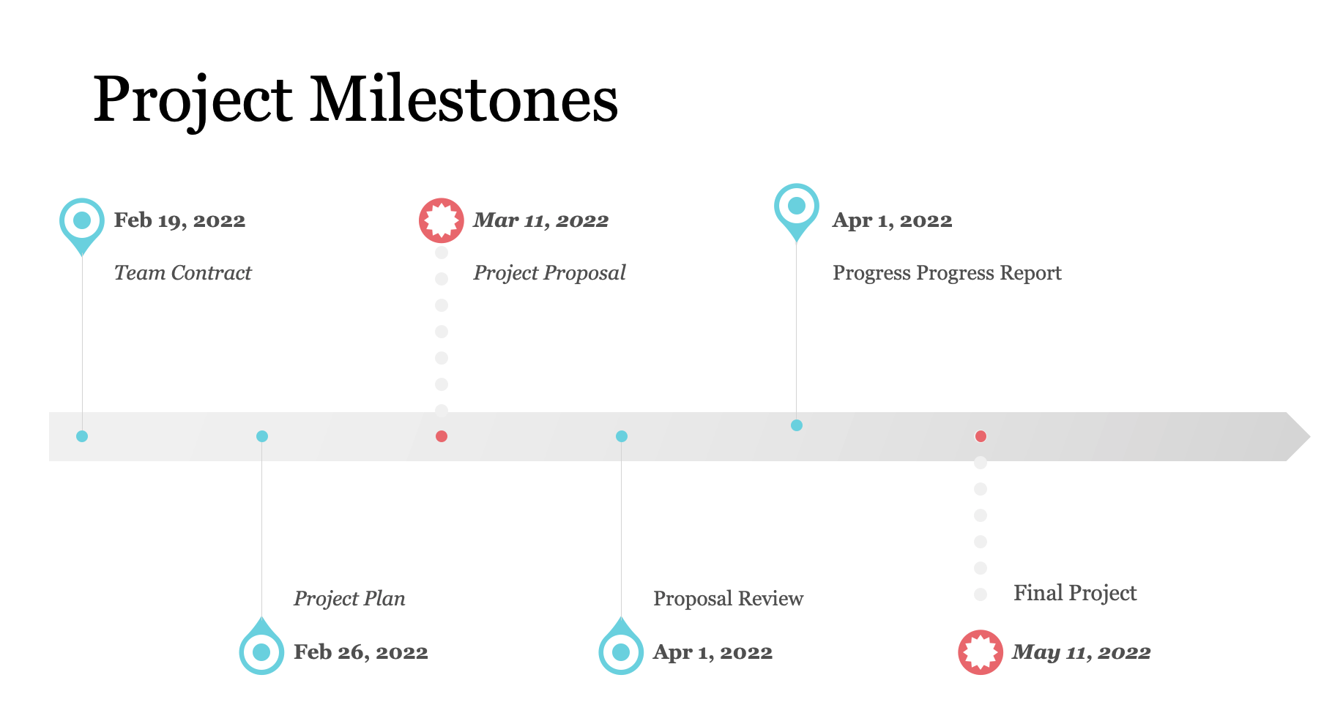

**Present two or three finalists for your team project topic with brief descriptions. In the next**

**deliverable, the Project Proposal, you will choose one of these and provide much more**

**detail. In this report, you should provide just enough description (2-3 sentences for each**

**idea) to demonstrate that the idea would work for the scope of the semester-long project.**

Our top two or three finalists for the team projects are Diseases, Personal Music Collection, and Reviews for restaurants.

**Project Topic Ideas:**

* Diseases database: this database will store all the diseases that are affecting people in the United States. It will show how a specific disease is affecting a certain population of the US depending on the age, gender, race, ethnicity, etc.
* Reviews for restaurants: this database will contain reviews of restaurants and can be sorted through different ratings such as quality of food, customer service, ambience, etc.
* Personal Music Collection, this database will consist of a user's personal music collection on Spotify. This database will include artist name, song name, album name, year, date acquired, etc.